**Please follow these steps to calibrate you AC voltage Sensors:**

**Caution is required when dealing with Live AC Circuit:**

**Step 1**:

Open the calibration codes folder and open the sine_cal code, so what this code will do is that it will help us see a sine wave when turning the potentiometer on the sensor, when you upload the code check on which pin the voltage sensor is connected to, then provide AC voltage on the terminals of the sensor and then open the serial plotter using CTRL+SHIF+L or go to tools and there should be a serial plotter there, once you open it you should see some waves on the screen, now turn the potentiometer it a blue colored one on the sensor turn it clock or anti clock wise until you see a sine wave type on the screen once you have done that we are done with step 1 and can move towards step 2 to calculate slope and gradient for our sensors, remember you have to do these steps for each AC voltage sensors that you will use separately.

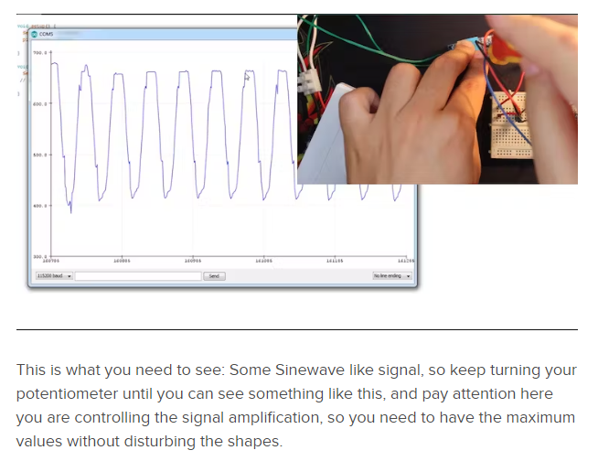

**Step 2:**

**Open the cal code and do the following procedure.**

How to get the intercept and slope? First keep them like above, intercept=0 and slope=1, in the code

Also below keep displaying Calibrated and non-calibrated values to help you in this process.

Put the AC input as 0 Volts on the screw terminals, upload the code and check the serial monitor, normally you should have 0

If you see another value and it is stable then the intercept will be the opposite of that value

Example you upload first time and then you see a stable 1.65V so the intercept will be -1.65

To set the slope now you need to put the voltage at something higher than 0, and measure that using your reference TRMS multimeter

Upload the new code with the new intercept and check the value displayed as calibrated values

Slope = (Measured values by multimeter)/(Measured values by the code)

Place your new slope and upload the code, if you have problems with calibration try to adjust them both Or add a new line to calibrate further. Slope and intercept have nothing to do with the TRMS calculation; it's just an adjustment of the line of solutions

Now after following the steps you have calibrated your sensor, please tell us if you were not able to do this on your own so we can schedule a meeting asap to help you get through this

Thanks.